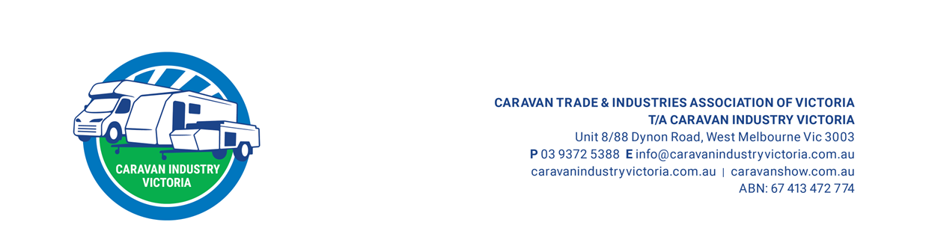
Media Release
For Immediate Release: 23 July 2026
___________________________________________________________________
Victorian Caravan Trade Expo to showcase industry innovation, insights and the future of caravanning
The Victorian Caravan Trade Expo is set to bring together leading manufacturers, suppliers and industry professionals for a day of innovation, education and collaboration, showcasing the latest products, emerging technologies and key trends shaping the future of caravanning. Taking place on Wednesday 29 July 2026 at Hyatt Place, Essendon Fields, the event will feature a comprehensive program of keynote presentations, State of the Industry Summits and new product showcases from some of the caravan industry's leading brands.
The day will feature an impressive lineup of keynote speakers, bringing together expertise from automotive innovation, aviation, economics and advanced manufacturing.
Mark Harland - EVs and How They Are Changing the Future of Caravanning - Fast
Australian Chief Executive Officer, BYD Denza
Mark Harland will explore how electric vehicles are enhancing and challenging the caravan industry, examining the impact of new technology and what the transition towards EVs means for businesses and their customers.
Matt Hall - Big Dreams, Small Margins
Red Bull Air Race Champion & RAAF Top Gun Fighter Pilot
A retired Wing Commander and combat veteran, Matt Hall will share lessons from his decorated aviation career, exploring ambition, resilience, decision-making and managing risk under pressure.
Jordan Edwards - The Road Ahead: Economic Trends Shaping the Caravan Industry
Chief Executive Officer, Soda Capital
Jordan Edwards will provide insights into the economic trends influencing the caravan industry and what businesses should be aware of as the sector continues to evolve.
Vikram Sachdeva - De-mystifying Industrial AI for the Caravan Industry
Director - Manufacturing Excellence & Transformation, Factory of the Future | Swinburne University of Technology, Australia
Vikram Sachdeva will explore the opportunities presented by Industrial AI and how emerging technologies can support innovation, efficiency and transformation across the caravan sector.
State of the Industry Summits
The Victorian Caravan Trade Expo will also host two State of the Industry Summits, providing an open forum for industry professionals to discuss the issues, opportunities and trends shaping the future of caravanning. The first session will explore the current manufacturing landscape, including supply chain challenges, innovation, workforce issues, market conditions and future opportunities, while the second session will focus on the challenges and opportunities facing the retail, servicing and repair sectors of the caravan industry.

New products and innovations on display
The Victorian Caravan Trade Expo will showcase the latest products, technologies and solutions from leading suppliers across the caravan industry, including:
- Diesel Heat – New RVC Controller, fuel tanks with drain valves and electronic sender units, and low-flow showerhead solutions.
- Airbag Man – New wireless air control app for enhanced suspension control and convenience.
- Filippi – Lightweight composite panels featuring PET-core, EPS, XPS and honeycomb structures for caravan interiors.
- Supex – New caravan lighting solutions, interior fans and awning accessories.
- Fixtech – New adhesive and sealant solutions, including Fix90, Fix30 and Fix6 products.
- HVG – Durasein solid surface, a silica-free, durable and hygienic surface solution designed for caravan and RV interiors.
With a strong focus on innovation, collaboration and the future of caravanning, the Victorian Caravan Trade Expo will showcase the products, ideas and industry expertise driving the sector forward.
Event Details
Date: Wednesday 29 July 2026
Time: 9:00am - 4:00pm
Location: Hyatt Place, Essendon Fields
Media are invited to attend the Victorian Caravan Trade Expo and can register for the event here.
Photos

-ENDS -

For more information:

Jamie Williams
Caravan Industry Victoria
Marketing Manager
0406 726 624
E: marketing@caravanindustryvictoria.com.au
W: caravanshow.com.au

BACKGROUND INFORMATION

Caravan Industry Victoria

Caravan Trades & Industries Association Victoria (T/A Caravan Industry Victoria (CIV)) has been the voice of Victoria’s caravan and camping industry since 1952, we advocate, represent and support our members to enhance performance and promote the industry. CIV is dedicated to promoting high standards and providing valuable services to its members and the broader community.

Originally formed by a group of caravan manufacturers, hirers and private individuals drawn to the “family lifestyle” caravanning offers, we now have more than 250 members made up of manufacturers, retailers, suppliers and service providers, including caravans, motor homes, fifth wheelers, tent trailers, tents, accessories, relocatable homes, hire facilities, sales and repair services in Victoria.

We represent the needs of our members to industry and government as well as assist with the promotion of their businesses and the industry.

We are committed to serving our members and ensuring that businesses get access to quality research, business support, marketing opportunities and the best advice within the sector.

Ninety-three per cent (93%) of the over 31,000 caravans and RVs manufactured in Australia are produced in Victoria, also meaning most industry businesses use Victoria as their source of the supply chain.

We draw in excess of 105,000 people annually to: the Victorian Caravan & Camping Supershow at Melbourne Showgrounds in March, Border Caravan & Camping Leisurefest at Wodonga Racecourse in April, Cranbourne Caravanning & Adventure Leisurefest at Cranbourne Racecourse in May, Melbourne Caravan & Camping Leisurefest at Sandown Racecourse in September, Bendigo Caravan & Camping Leisurefest at Bendigo Racecourse in November and the Geelong Caravanning & Adventure Leisurefest at the Geelong Racecourse in November.

We also conduct large member and industry events, such as the Hall of Fame and Industry Awards at the Palladium at Crown Casino and the Trade Expo at Hyatt Place. At the Hall of Fame CIV recognises individuals and businesses for their excellence.

We also lead a $3.5 billion dollar industry in Victoria that employs over 12,500 in numerous professions by setting industry standards and conducting industry development activities such as accreditation programs, testing and certification, consumer and industry education, leading technical and regulations, legal advice and business development activities.

